IDEATION PHASE
Define The Problem Statement

DATE | 31 January 2025
TEAM ID | LTVIP2025TMID30643
PROJECT NAME | Visualization tools for electric vehicle charge and range analysis
MAXIMUM MARKS | 2 marks

Customer Problem Statement Template:

EV Charge and Range Visualization Tools are digital modules that transform electric vehicle battery and driving data into simple, visual insights. They display key information such as state of charge, energy usage, and estimated driving range in an easy-to-understand format.

These tools help users predict range more accurately, plan trips efficiently, and optimize charging decisions. By presenting complex data clearly, they reduce range anxiety and improve overall confidence in electric vehicle usage.

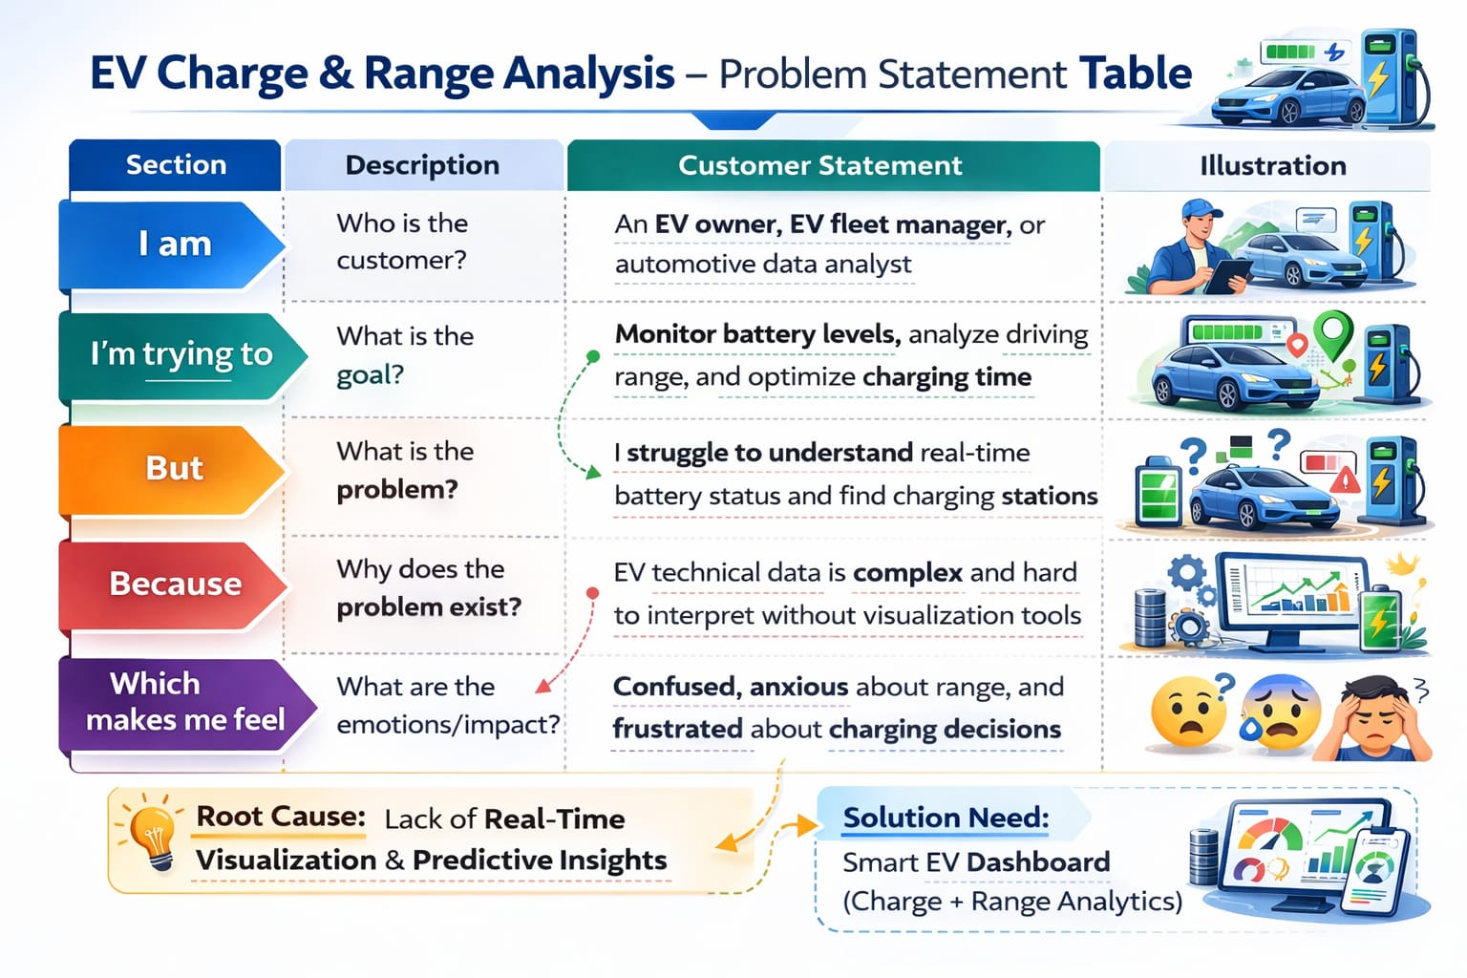

Reference: https://miro.com/templates/customer-problem-statement/

Example:
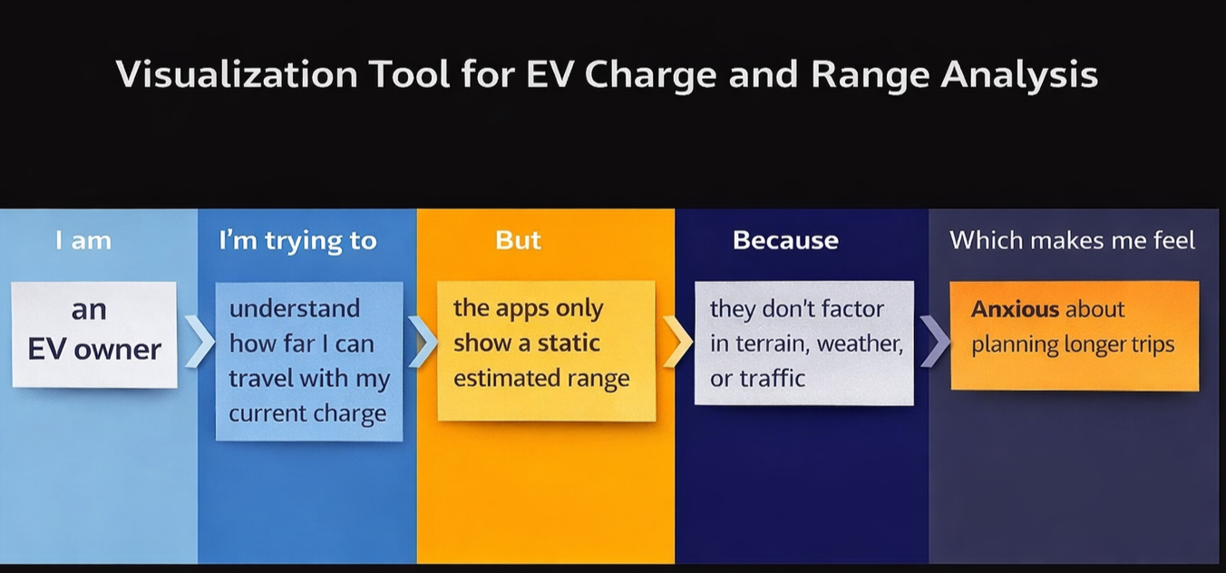

Problem Statement (PS) | I am (Customer)  I’m trying to | I’m trying to | But | Because | Which makes me feel
Ps-1 | An Electric Vehicle owner | Monitor battery charge level and predict remaining driving range accurately | The data is scattered and difficult to interpret | There is no clear, real-time visualization tool integrating battery, terrain, traffic, and driving behavior | Anxious about range and charging availability
Ps-2 | An EV fleet manager | Track vehicle efficiency, charging cycles, and range performance | The analytics tools are complex and not centralized | Vehicle data, charging data, and route data are stored in different systems | Frustrated and inefficient in decision-making

